7th Grade Final Science Project
“Build your Own Electric Motor”

I can’t believe we are so close to the end of the year. Wow, it has flown by!
For our last project, we are going to be building electric motors. The motors will be built at school during science class.

Students who bring in the materials will get to keep the motor they build, and will also receive extra credit.

I will provide the wire, both for the support/circuit and for the electromagnet. I will also provide the heavy duty staples to secure the heavy wire to the base.
We will begin constructing our magnets on Monday 4/22/13.
Feel free to paint or decorate your piece of wood before you bring it to school. You can also decorate it with markers at school.

Students will need to provide the following to build and keep their own motor:

1. 2 x 4 Piece of Wood. At least 6 inches long, no longer than 8 inches. If it is longer, we can cut them down to size here at school (I will teach the kids to use a hand saw).
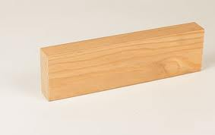 2x4 piece of wood.
2. Ring magnet. This is a flat ceramic magnet with the poles on the flat sides. Square/rectangular magnets will also work, as long as they are flat like a ring magnet. It does not have to have a hole in the middle.

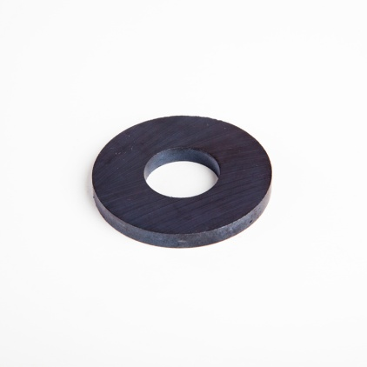
3. A “D” battery to power the motor.
We will begin constructing our magnets on Monday 4/22/13.
Feel free to paint or decorate your piece of wood before you bring it to school. You can also decorate it with markers at school.
